 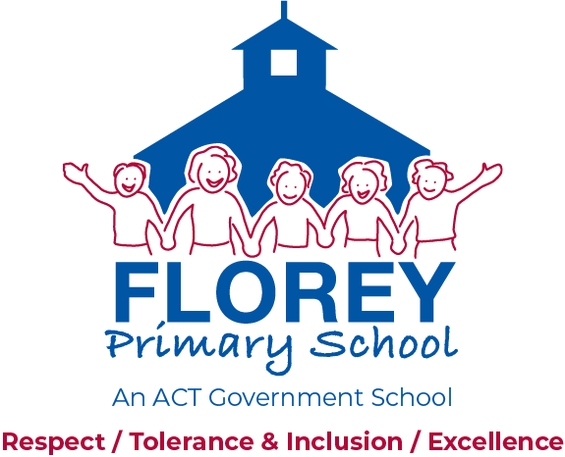

57 Ratcliffe Crescent, Florey ACT 2615 Telephone (02) 6142 2730

PO Box 223, Kippax ACT 2615 Website: [*www.floreyps.act.edu.au*](http://www.floreyps.act.edu.au)

Florey Primary School Facebook Page Guidelines and Procedures

This procedure must be read in conjunction with Florey Primary School Communications Guidelines

Table of Contents

Florey Primary School Facebook Page Guidelines and Procedures 1

1. Overview 1

2. Rationale 1

3. Procedures 1

4 Contact 4

5 Complaints 4

6 References 4

1. Overview
   1. These guidelines set out how the school will present information on Facebook and how parents, students and citizens must behave in their comments and reactions. They describe the rationale for the guidelines, appropriate posts and the methods of monitoring and responding to posts.
   2. Florey Primary School Facebook Guidelines provide a framework for effective and respectful communication that:

* is a positive publicity point for the school to the greater community
* promotes positive communication between the school and families
* streamlines communication
* shares information and updates about the school and community

1. Rationale
   1. Florey Primary School believes effective communication between members of the school community is fundamental to:

* encouraging positive partnerships and participation
* supporting family participation
  1. Facebook as a communication medium has a unique set of requirements to ensure safe and appropriate use of content by all users.

1. Purpose
   1. Communication via the Florey Primary School Facebook page will provide relevant and updated information to parents/carers and community.
   2. **Facebook Administrator Procedures:**

* two elected staff members will check content and answer and direct any queries
* administrator will consider requests for posts, reminders and events on the page
* posts made by ‘fans’ will be managed using the developed guidelines (see below)
* deleting content that brings the Directorate, school or individual into disrepute
  1. **Community responsibilities-** By posting comments on the Florey Primary School Facebook Page you are agreeing to adhere to the following: -

Our community guidelines aim to ensure that our Facebook page is inclusive and inviting for everyone.

**Comment moderation policy**

Please be mindful of others. Comments will be removed if considered offensive, threatening or unlawful.

You may not submit content that: is threatening, abusive, defamatory, indecent, menacing, harassing, offensive, infringes any person’s intellectual property rights, harasses anyone or is unlawful in any way.

We have a zero tolerance policy towards racism and if you post something of this nature your comment will be deleted.

3.4 **Wall post guidelines**

The following guidelines provide advice to ensure wall posts will not be deleted.

3.4.1 Florey Primary School (and The Education Directorate), cannot endorse any sites referred to by fans in any comments or discussion submissions. Parents/carers please ensure you monitor your child's internet usage and check the sites they are accessing.

3.4.2 Views expressed on our wall may not be the views of Florey Primary School.

Please make sure your comments are appropriate before submitting them. Inappropriate comments could be anything that is:

* inclusive of photos of students or teachers (even with permission) – This is in connection to the Florey Primary School Photo and Video Guidelines <http://www.floreyps.act.edu.au/our_school/policies_and_procedures>
* inclusive of information identifying student or teacher identities and/or contact information

• off-topic or spam

(Posts that are considered ‘spam’ and all content that breaches Facebook’s independent policies and statement of rights and responsibilities will be removed)

• soliciting funds, goods or services, or advertising

• racially, ethnically or religiously offensive

• defamatory

• threatening, harassing or abusive

• obscene, profane or vulgar

• illegal or encouraging of criminal acts

• known to be inaccurate or contains false attribution

• infringing on copyright, trademark or any other rights of others

• impersonating anyone else (actual or fictitious).

* + 1. Please note that any posts deemed inappropriate will be deleted.

3.5 **Disclaimers**

* Facebook Accounts for Florey Primary School are maintained and moderated by elected school staff
* A ‘like’ or reaction by a school account does not reflect an official school review
* A ‘like’ or reaction by a Facebook ‘fan’ of a Florey post does not reflect an endorsement by the school of that Facebook user
* Where links are provided to external websites it is done as a convenience to users and may not be under Florey Primary School’s control.  Florey Primary School does not take responsibility for the content or reliability of external links, or for any loss or inconvenience arising from their use
* Florey Primary Schools’ social media accounts are open for public comment but does not endorse, and is not accountable for, any views expressed by third parties using social media, external content, links and views are those of the original author
* Please be aware that all websites and social media sites are public spaces on the internet. Most interactions are publicly viewable, can be traced back to their origin and are searchable over time
* When the community uses Facebook they are using an external site. Facebook has its own guidelines and legal policies and the community are bound by their terms and conditions of use. Florey Primary School encourages everyone to read the information posted on the sites before participating in Facebook

4 Contact

* 1. Florey Primary School is responsible for this procedure.
  2. For support contact Florey Primary School on (02) 6142 2730.

1. Complaints

5.1 Any concerns about this procedure or its application should be raised with:

* the school principal in the first instance
* the Directorate’s Liaison Unit on (02) 6205 5429
* online at <http://www.det.act.gov.au/contact_us>
* see also the *Complaints Policy* on the Directorate’s website.

1. References
   1. **Definitions**
      1. ‘Community’ refers to parents and carers, students, staff and other stakeholders such as Board members
      2. ‘Families’ refers to parents and carers of students
   2. **Related Policies and Documents** - Link to related policies or other documents.

* Florey Primary School Communications Guidelines
* Florey Primary School Photography and Video Guideline

*The guidelines were developed by Florey Primary School Board through consultation with the school community in 2015. Last date reviewed: October 2019. Date next review: November 2021*