 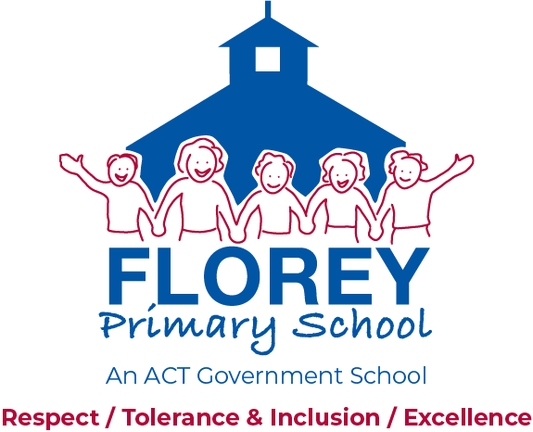

57 Ratcliffe Crescent, Florey ACT 2615 Telephone (02) 6142 2730

PO Box 223, Kippax ACT 2615 Website: [*www.floreyps.act.edu.au*](http://www.floreyps.act.edu.au)

**GUIDELINES TITLE: HOME LEARNING**

**PUBLISHED: 2015**

**LAST REVIEWED: 2019**

**IDENTIFIER: 201704**

**CONTACT: Principal, Florey Primary School**

**RELATED DOCUMENTS:** Education Capital: Progressing Parental Engagement ([www.det.act.gov.au/teaching_and_learning/parental-engagement](http://www.det.act.gov.au/teaching_and_learning/parental-engagement))

**_______________________________________________________________________________________**

**PURPOSE**

These guidelines outline the Florey Primary School approach to home learning. They describe what home learning is, the rationale for home learning, and guidelines for implementing and participating in home learning.

**1. POLICY CONTEXT**

* 1. In developing these guidelines, the School Board surveyed parents, teachers and students (in years 3-6). Responses revealed a very diverse range of views across the community.

* 1. The Board also reviewed relevant literature on potential benefits, limitations and recommendations for homework/home learning in primary school. In summary, there is limited and inconclusive evidence that home learning contributes directly to improved academic achievement for primary aged students, and general consensus that it can provide effective support for non-academic goals.
  2. Research shows effective partnerships between families and schools, and positive parental engagement in children’s learning have strong and wide-ranging benefits. The ACT Education and Training Directorate has released evidence-based information and practical strategies for schools and families to support parental engagement, such as reading together, learning together, creating a positive homework environment and effective parent-school communication. Resources are available on the Directorate’s website (www.det.act.gov.au).
  3. These sources, and the views of all members of the school community, contributed to the development of the rationale, principles and procedures for home learning outlined below.

**2. DEFINITIONS**

**2.1** Children have opportunities to learn in many environments, with family, peers and the wider community. For the purpose of this document, the term **home learning** is used to describe an experience or activity that has been assigned by teachers to be completed by students outside of school hours.

1. **RATIONALE**

**3.2** The Florey Primary School Home Learning guidelines aim to encourage a strong sense of community where staff, parents/carers and students can share ideas and knowledge in an inclusive environment that contributes to providing the best possible learning outcomes for our children.

**3.3** These guidelines provide a framework for the organisation of home learning across the school on the basis that it provides opportunities:

* for students to share some of what they are learning at school with parents and caregivers
* for parents to see some of what their children are learning, which can help them to help their children connect what they learn at school to other contexts
* help students learn to manage their time and develop study skills
* use resources additional to those available at school.

**4. PRINCIPLES**

**4.1** Through this consultation and review of research, Florey Primary School believes that home learning activities should:

* be a positive experience for students and parents
* reinforce what students learn at school
* interest, challenge and encourage students in their learning
* foster good study habits through a range of tasks such as reading; problem solving and analysis; creative and practical work; written and oral presentation
* be considerate of time constraints for families and therefore allow appropriate and realistic time frames (and not generally set over school holidays)
* reflect a shared understanding and consistent approach within teaching teams
* not impact on student grades
* not be completed where undue stress is resulting in the home environment.

**5. PROCEDURES**

**5.1 Teaching Team’s Role**

* take into consideration the importance of children spending time in cultural and sporting activities outside of school hours
* develop procedures and expectations for home learning at the beginning of each year
* communicate procedures to parents through the term overview and information evening in term one
* give explicit instructions, monitor and provide feedback to students and parents
* provide learning that is appropriate to the age and grade of students, sufficiently open-ended to take into account abilities that are represented in the class
* provide scaffolding and examples to assist parents to help students
* provide links to suitable websites for research work
* ensure that home learning complements class learning and does not include new curriculum tasks
* state, and focus marking/feedback on, clear learning intentions

**5.2 Parent’s Role**

* provide an environment for the child that is conducive to completing home learning
* contact their child’s teacher if there are concerns about specific activities or more general issues related to home learning
* encourage their child to seek assistance from the teacher if necessary.

**5.3 Student’s Role**

* accept responsibility for the completion of work and finish tasks to the best of his/her ability within the given timeframe
* ask for assistance from teachers and family where necessary.

**5.4 School’s Role**

* A list of recommended websites for student directed home learning will be made available on the school’s website.
* Progressively make available online, a set of school resources that help parents support home learning, using approaches that are consistent with what children are doing at school. This includes resources such as reading strategies, key numeracy strategies (eg. mental computation), graphic organisers, internet research strategies, simple referencing expectations, and structure/tips for key text types (report, persuasive, narrative, presentation).

**6. SUGGESTED ACTIVITIES AND TIMEFRAMES**

|  |  |  |
| --- | --- | --- |
| **Grade** | **Activities** | **Recommended Time** |
| **Preschool** | *Reading to your child  *Activities that encourage independence (e.g. tying shoelaces, dressing, packing bag for preschool)  *Activities that encourage the development of gross motor skills, e.g. climbing at the park, riding tricycles or bikes, kicking/throwing balls, skipping jumping, hopping | Daily |
| **Kindergarten** | *Reading and sharing books with family members | Daily 5-10 minutes |
| *Talk to family members  *Occasional tasks sent home to support curriculum (e.g. family tree for history) |  |
| **Year 1/2** | *Reading and sharing home readers and/or books with family/carers and friends | Daily 10 -15 minutes |
| *Specific home learning activities  *Occasional tasks sent home to support curriculum | Up to 30 minutes per week |
| **Year 3/4** | *Reading and sharing home readers and/or books with family/carers and friends | Daily 15 minutes |
| *Choice of three home learning activities per week based on literacy, numeracy and one other curriculum area. | Up to 1 hour per week |
| **Year 5/6** | *Reading and sharing a range of texts with family/carers and friends | Daily 15-20 minutes |
| *To support students to develop time management and homework skills, the year 5/6 teaching team plan an assessment task associated with an area of the curriculum.  *students are supported through the provision of a rubric, a recommended timeline for when to have work checked and submitted; and the option of using study club at school.  * The homework assessment item goes towards the students grades, along with other items of work completed in class. | Up to 1 ½ hours per week |

**7. GUIDELINES OWNER**

**7.1** Florey Primary School Board

**8. RELATED POLICIES**

**8.1** Florey Primary School Communications Guidelines

ACT ETD complaints Policy

ACT ETD Acceptable use of ICT Policy

*These guidelines were developed by Florey Primary School Board through consultation with the school community in 2015. Last date reviewed: August 2019. Date next review: August 2021.*