 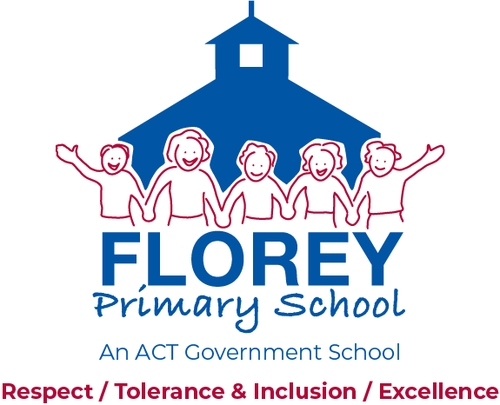

57 Ratcliffe Crescent, Florey ACT 2615 Telephone (02) 6142 2730

PO Box 223, Kippax ACT 2615 Website: [*www.floreyps.act.edu.au*](http://www.floreyps.act.edu.au)

**GUIDELINES TITLE: PHOTO AND VIDEO GUIDELINES**

**PUBLISHED: September, 2013**

**LAST REVIEWED: November 2019**

**IDENTIFIER: 201301**

**CONTACT: Principal, Florey Primary School**

**RELATED DOCUMENTS: Nil**

Florey Primary School Photo and Video Guidelines provide a framework for students, their families and other community members when undertaking photography or video recording of their students only at school events.

The Florey Primary School community believes that families who wish to record their child’s participation in school events through photography or video recording should be able to do so in a manner that is **mindful of the welfare of children and respectful of the privacy concerns** of the school community.

The right to privacy is one of the rights protected under the ACT’s *Human Rights Act 2004*. Parents and carers, and children themselves, have a reasonable expectation of privacy under the Act. These guidelines support the right to privacy of students in relation to photographs and video recordings taken of students at school events.

Photography and video recording of students and student activities will be permitted at the following school functions (individual and own children/excluding other children where possible).

* In the event that this is not possible then images and video containing other students should not be published in any form of social media or public forum
* school assemblies
* school concerts
* sporting events and carnivals (excluding swimming carnivals)
* graduation and award ceremonies
* dramatic and cultural events and performances where appropriate
* school excursions; and
* school special events (such as Learning Journeys).

Photography and video recordings will **NOT** be permitted at swimming carnivals.

* Parents and carers should limit their photography or video recording to events where their child is participating
* It is acknowledged that on occasion parents and carers will ask others to photograph their child at an event where they themselves cannot be present
* In this situation parents and carers should ensure that any photographs or video footage are distributed only to the parents or carers of those children they have been requested to photograph or take footage of.
* Once photographs or video recordings have been made of an event, many families are concerned about how those images will be used or disseminated
* We actively discourage the distribution of video footage or still images of children from other families through printed or electronic media, and in particular social media
* Parents and carers can treat photographs or video footage of their own children as they see fit
* Images of children from other families, including images of your own children where other children are incidentally included, should **NOT** be distributed via any medium.

*The guidelines were developed by Florey Primary School Board through consultation with the school community in 2013. Last date reviewed: November 2019. Date next review: November 2021.*