Parking and traffic management guidelines

Managing traffic and road safety at schools is a matter for everyone in the community. Children are more at risk in road environments around schools because they are smaller and less visible to drivers. Their behaviour can be less predictable than adults and they may have errors of judgement when dealing with traffic.

School environments are often congested during the peak times, because roads and carparks aren’t built to meet the high demand and struggle to cope over a short timeframe. The school community can help to reduce congestion and improve safety for children by walking or riding to school. If you need to drive, consider part way drop off or collection points or follow these traffic management guidelines to ensure children remain safe.

More information is available on the Transport Canberra website, including a range of educational resources for school communities to promote active and safe behaviours around schools.

Parking and traffic management guidelines

- Please drive slowly and be patient and courteous to others when visiting the school.
- Motorists should always park legally. There is parking available on the streets and carparks around the school (refer to maps).
- Illegal parking reduces visibility of children and creates a potential safety risk. Police, Parking Operations and a Licence Plate Recognition vehicle undertake periodic patrols in school environments to enforce safe behaviours.
- Motorists should never park in the Pick Up and Set Down zone within the school carpark. Please only use this area to drop off or collect children.
- Motorists should never double park to collect children, it creates an unnecessary safety risk to children and reduces traffic flow.
- Always drive very slowly through the carpark (10km/h) and be alert for children.
- Stopping or driving on the verge is dangerous for children, who shouldn’t be required to navigate cars in these areas.

Useful tips and resources

- Walking and riding to school is a safe, fun and healthy form of travel and is encouraged and supported by the school.
- Children can be dropped at school between 8:30-9:00am. By dropping children before 9:00am, you are likely to avoid congestion.
- Arrange an alternative meeting point with your child/ren to avoid the congestion at the front of the school, which might be a five to ten-minute walk from the school (refer to maps for some examples). This will help you to avoid the school peak, which is at its worst from 2:55-3:05pm.
- Carpooling, public transport and active travel are all encouraged forms of transport.

Illegal driving practices

By following these suggestions, parents will create a safer environment for children and avoid incurring fines which include:

- Parking on the verge (fines from $120)
- Parking on footpaths (fines from $120)
- Stopping in a No Stopping zone (fines from $270)
- Parking in a No Parking zone (fines from $120)
- Stopping on a pedestrian or children’s crossing (fines from $405)
- Parking in a Bus Zone (fines from $162)
- Parking in a mobility (disabled) space (fines from $600)

Florey district map

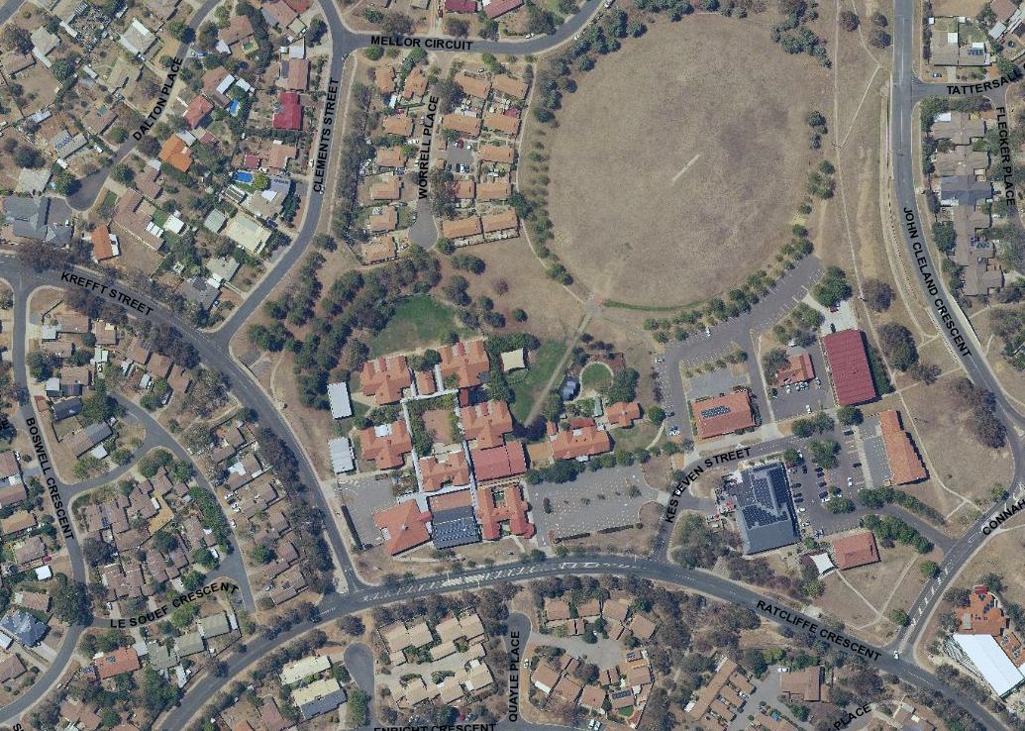
.
.
School carparks
Untimed parking
On street parking or part way pick up or drop off locations
Florey Primary School carpark and frontage
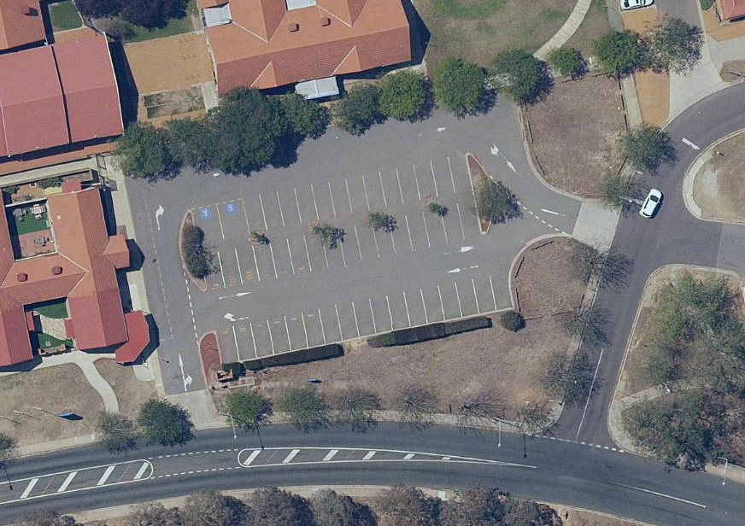
Parking in the Pick Up/Set Down zone creates congestion. Parents are encouraged to do a lap or find a carpark if their child isn’t waiting
Never double park to collect or drop children (red area), it reduces traffic flow and reduces safety for children
Parking on the verge is illegal, it reduces visibility and safe walking locations for children

